AWX-Management Setup

Contents

1. Git Project Creation 2

1.1 Setup AWX-Management Project 2

1.2 Setup Ruckus-ICX-AWX-Ansible Project 4

1.3 Setup AWX-ZTP Project 5

2. Setup Credentials for AWX-Management 6

2.1 Create a Custom Credential Type 6

2.2 Add AWX Login Credentials 8

3. Setup Localhost Inventory 9

3.1 Create AWX Server Inventory 9

3.2 Add AWX Server Host 10

4. Setup AWX-Management Template 11

4.1 Create AWX-Template-Management Template 11

4.2 Generate AWX-Template-Management Survey Prompt 13

5. Generating New Templates 15

5.1 Create templates for Ruckus-ICX-AWX-Ansible 15

5.2 View Templates 16

6. Updating Playbooks and Templates 18

6.1 Manual update of project playbooks 18

6.2 Automated update of project playbooks 19

6.3 Automated update of project templates 21

7. Custom Template Creation 23

8. Setup AWX-ZTP 25

8.1 Setup Localhost SSH Credentials 26

8.2 Create 'ZTP-Install' Template 27

8.3 Launch "ZTP-Install" 28

8.4 Launch "ZTP-Configure" 32

8.5 Workflow Creation 36

8.6 Adding Workflow to ZTP 50

# 1. Git Project Creation

## 1.1 Setup AWX-Management Project

To add the AWX-Management playbooks to a project, first click on the **Projects** menu on the left, then click the **+** button:

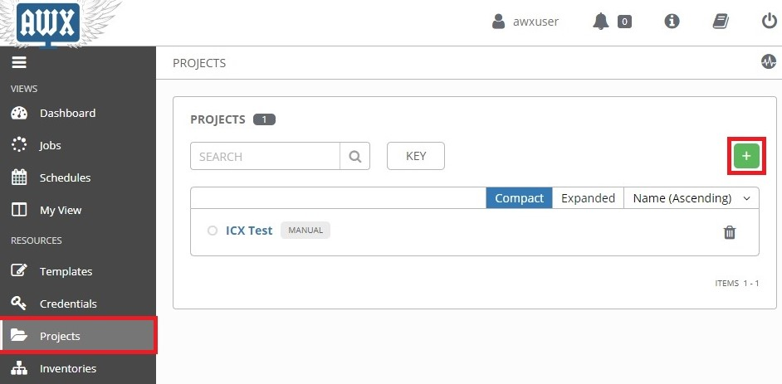

This opens the **New Project** page:

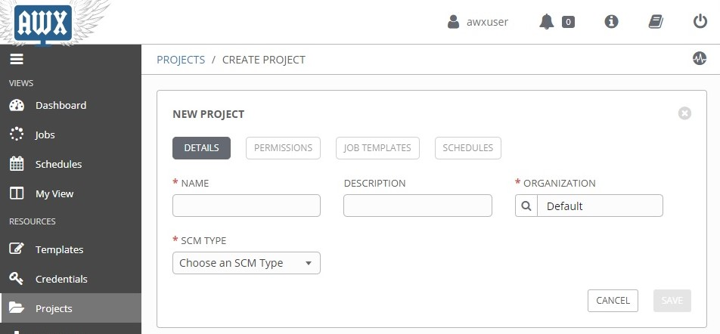

Enter the following into the required fields:

**NAME:** Name the project "*AWX-Management*"

**SCM TYPE:** Select "*Git*"

**SCM URL:** Type in "*https://github.com/steppb/AWX-Management*".

**Organization:** A project must have at least one organization. Here, "*Default*" is selected.

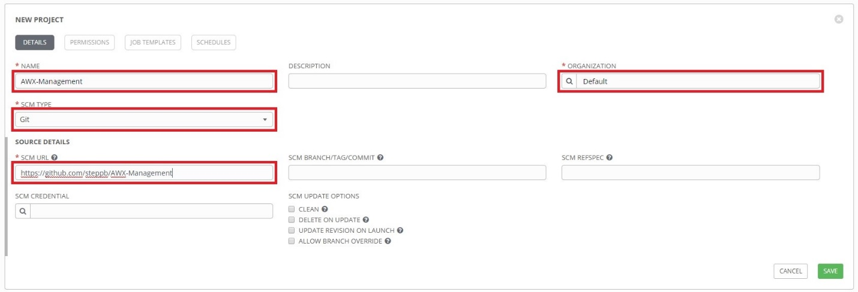

When you are finished, click **Save**.

At this point **AWX-Management** will be added to the list of projects and it will begin syncing with the Github repo. An animated green circle next to the project indicates the project is currently syncing. A static green circle indicates the project has successfully finished syncing and the playbooks are ready for use:

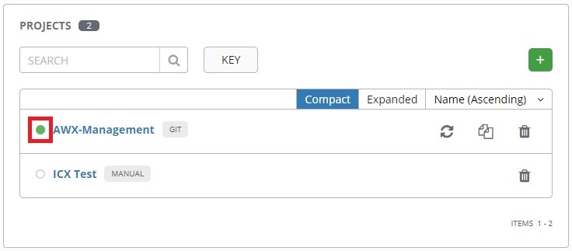

A red circle would indicate a failure during syncing. You can click on the circle to bring up a status window showing the details of the syncing process.

## 1.2 Setup Ruckus-ICX-AWX-Ansible Project

To add the "Ruckus-ICX-AWX-Ansible" playbooks to a project, first click the **Projects** menu on the left, then click the **+** button:

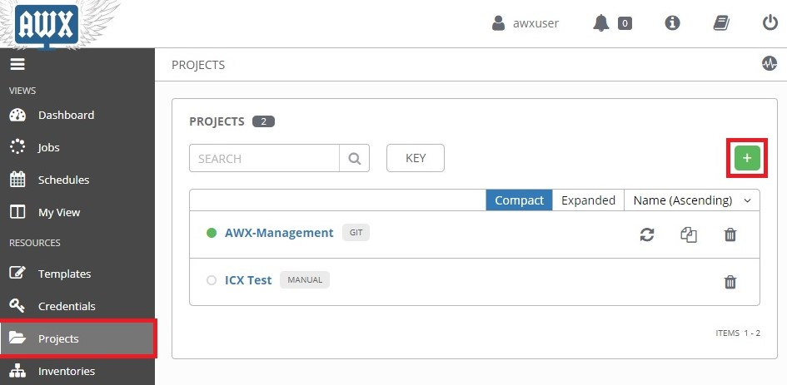

This opens the **New Project** page. Enter the following into the required fields:

**Name:** Enter the name of the project. Here, it is named "*Ruckus-ICX-AWX-Ansible"*.

**SCM Type:**  Select "*Git*".

**SCM URL:** Enter "*https://github.com/steppb/Ruckus-ICX-AWX-Ansible".*

**Organization:** A project must have at least one organization. Here, "*Default*" is selected.

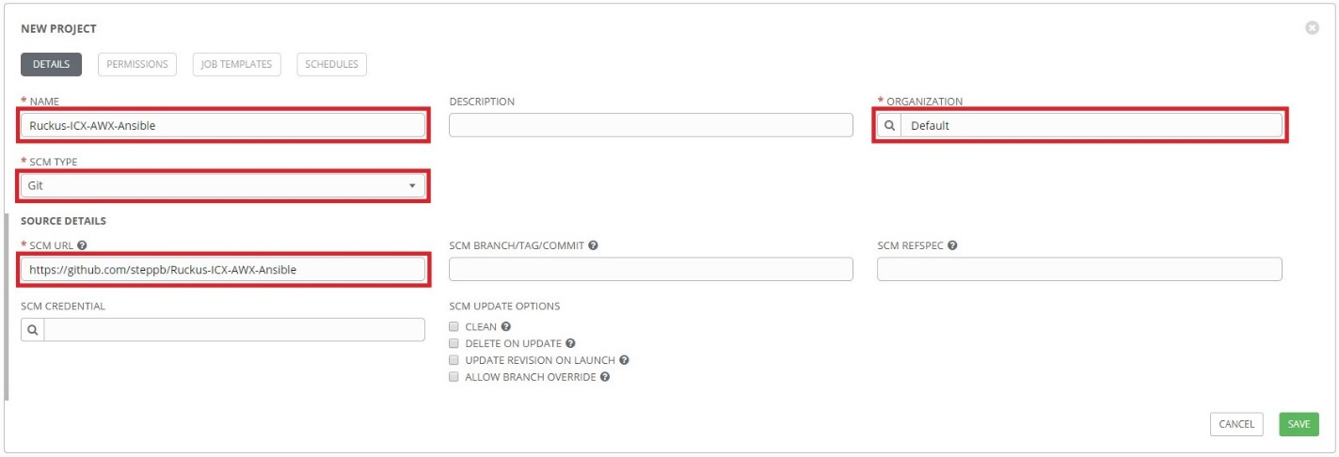

When you are finished, click **Save**.

## 1.3 Setup AWX-ZTP Project

To setup the AWX-ZTP project, first click **Projects** from the left navigation bar, then click the **+** button. Complete the following fields on the **New Project** page:

**NAME:** Name the project "*AWX-ZTP*"

**ORGANIZATION:** Ensure an organization is selected.

**SCM TYPE:** Select **Git**.

**SCM URL:** Enter "*https://github.com/steppb/AWX-ZTP*".

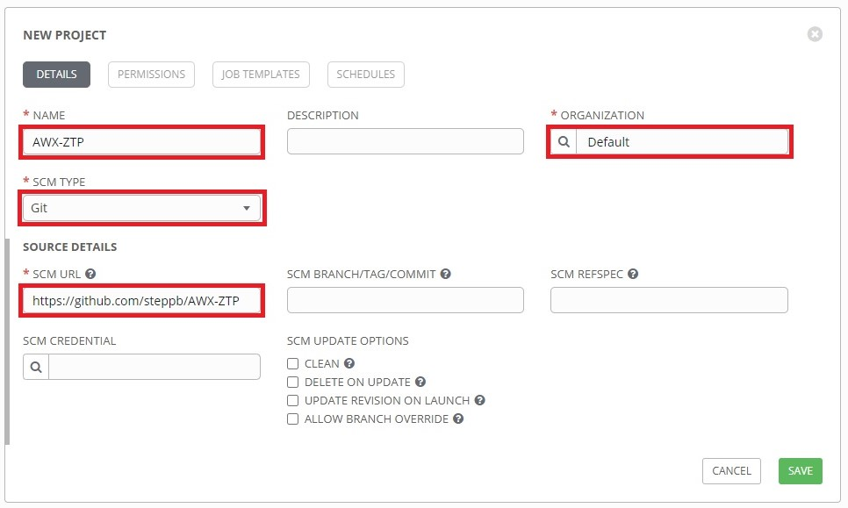

Click **Save**, when finished.

# 2. Setup Credentials for AWX-Management

The "AWX-Management" playbooks contain variables that need to be defined with credentials for logging into the AWX REST API framework. In order to accomplish this, a custom credential type will need to be created.

## 2.1 Create a Custom Credential Type

First, click the **Credential Types** menu on the left, then click the **+** button:

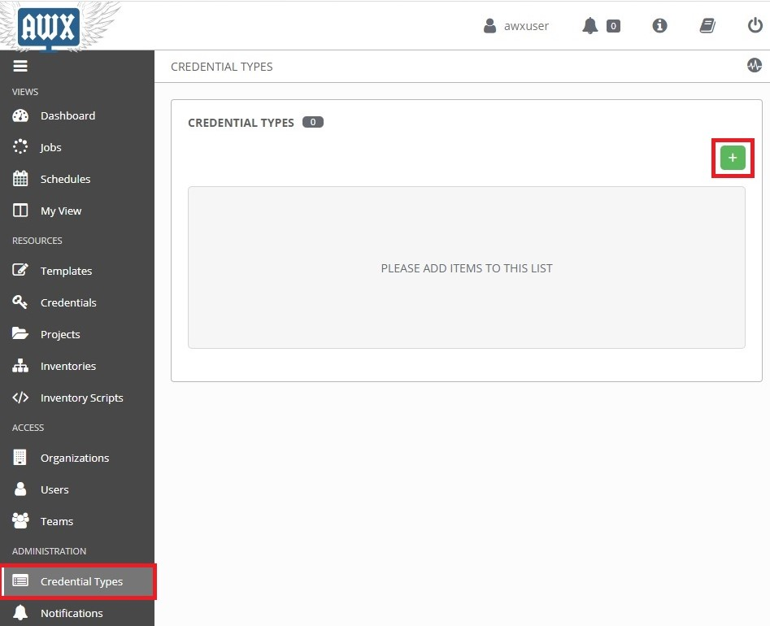

This opens the **New Credential Type** page.

Enter the following into the required fields:

**NAME:** Enter the name of the credential type. Here, it is named "*AWX REST API*"

**DESCRIPTION:** (Optional) Enter a description.

**INPUT CONFIGURATION:** Ensure **YAML** is selected. Then copy and paste the following into the box:

|  |
| --- |
| fields:  - id: username  type: string  label: AWX Username  - id: password  type: string  label: AWX Password  secret: true  required:  - username  - password |

**INJECTOR CONFIGURATION:** Ensure **YAML** is selected. Then copy and paste the following into the box.

|  |
| --- |
| extra_vars:  awxlogin_user: '{{username}}'  awxlogin_pass: '{{password}}' |

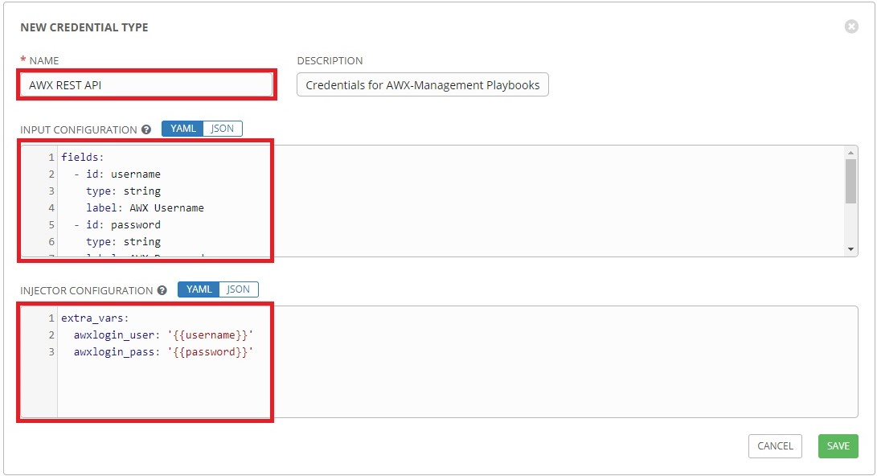

When you are finished, click **Save**.

Now that the custom credential type has been set up, a credential set for the AWX-Management playbooks can be created.

## 2.2 Add AWX Login Credentials

Click on the **Credentials** menu on the left, then click the **+** button:

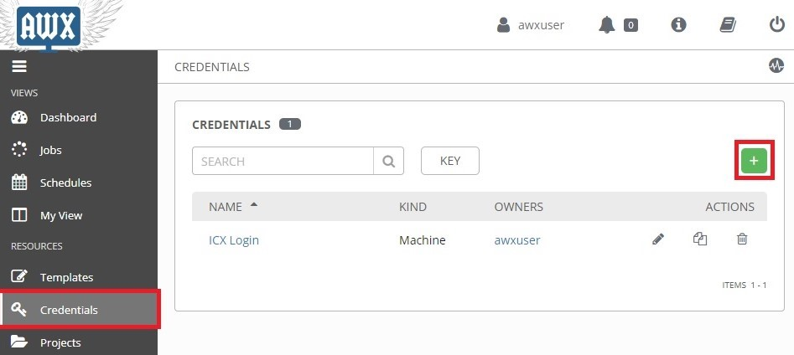

This opens the **New Credential** page.

Enter the following into the required fields:

**NAME:** Name of the credential set. Here it is named "*AWX Login*"

**CREDENTIAL TYPE:** Select the custom credential type. Here it is named "*AWX REST API*"

**AWX USERNAME** & **AWX PASSWORD:** Type in the credentials used to login to AWX.

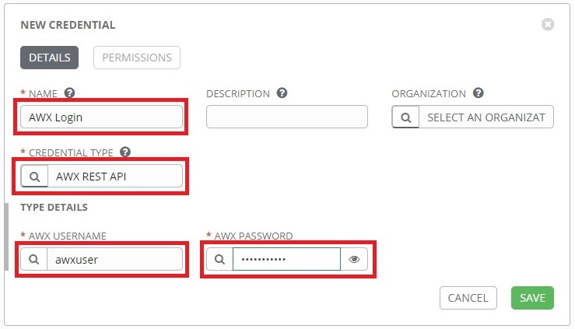

When you are finished, click **SAVE**.

# 3. Setup Localhost Inventory

## 3.1 Create AWX Server Inventory

An inventory for the AWX Server itself will need to be setup in order to execute the AWX-Management templates against itself.

Click the **Inventories** button from the left navigation bar. Click the **+** button, then click **Inventory** from the drop-down menu:

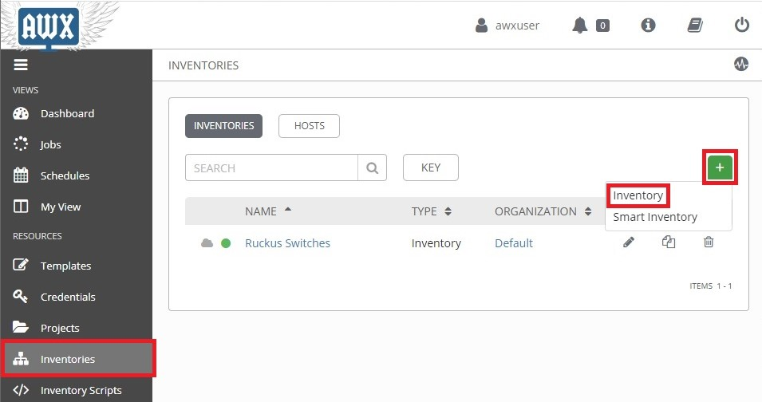

This opens the **New Inventory** page.

Complete the following fields:

**NAME:** Enter a name for the Inventory. Here the inventory is named "*AWX Server*".

**Organization:** Select the organization the inventory belongs to. Here "*Default*" is selected.

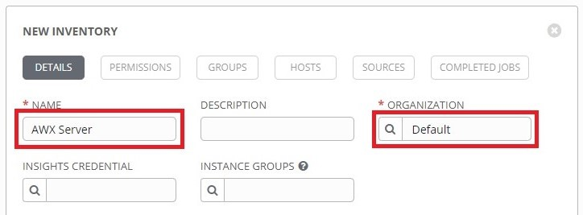

When you are finished, click the **Save** button.

## 3.2 Add AWX Server Host

Click the **Hosts** tab, then click the **+** button:

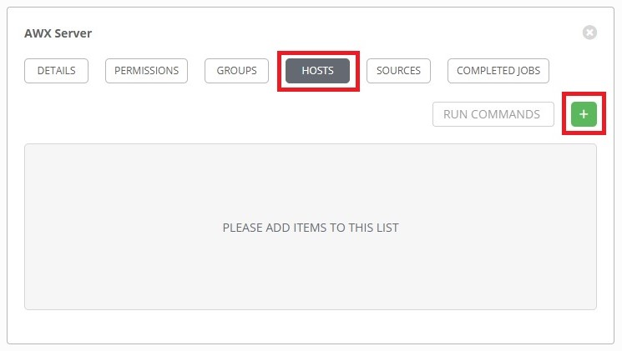

This opens the **Create Host** page.

Complete the following fields:

**HOST NAME:** Enter the hostname of the AWX server. Here it is called "*awxserver*".

**VARIABLES:** Type in "*ansible_host:* " followed by the IP address of the AWX server.

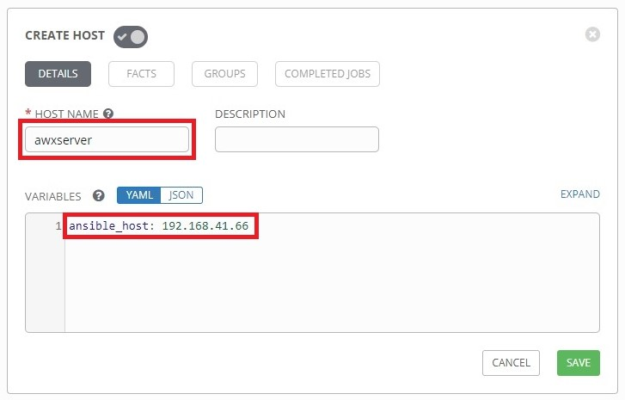

Click **Save** when done, and the AWX server will be added to the Inventory's list of hosts.

# 4. Setup AWX-Management Template

## 4.1 Create AWX-Template-Management Template

Click the **Templates** button from the left navigation bar. Click the **+** button, then click **Job Template** from the drop-down menu:

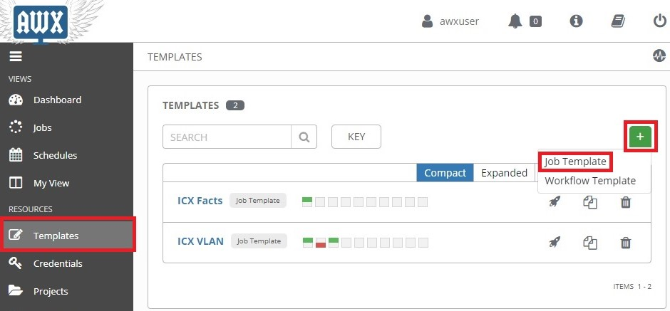

This opens the **New Job Template** page.

Complete the following fields:

**NAME:** Enter a name for the template. Here it is named "*AWX-Template-Management*"

**DESCRIPTION:** (Optional) Enter a description of the template.

**JOB TYPE:** Select **Run**.

**INVENTORY:** Select the inventory that contains the AWX server. Here it is "*AWX Server*"

**PROJECT:** Select **AWX-Management**.

**PLAYBOOK:** Select **AWX-Template-Management.yml**.

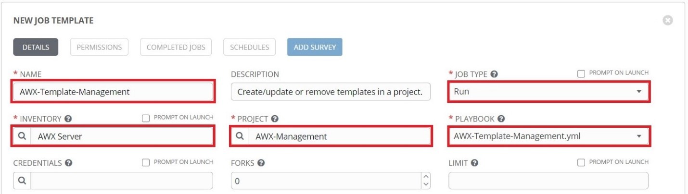

**CREDENTIALS:** Click the  button to open a separate window. Select the custom credential type in the **Credential Type** drop-down menu, then select the AWX Login credentials:

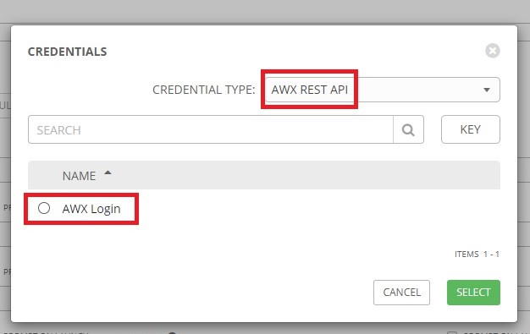

Click **Select** when done, then click **Save** to save the template.

## 4.2 Generate AWX-Template-Management Survey Prompt

Click the **Templates** button from the left navigation bar. Then click the launch () button next to **AWX-Template-Management**:

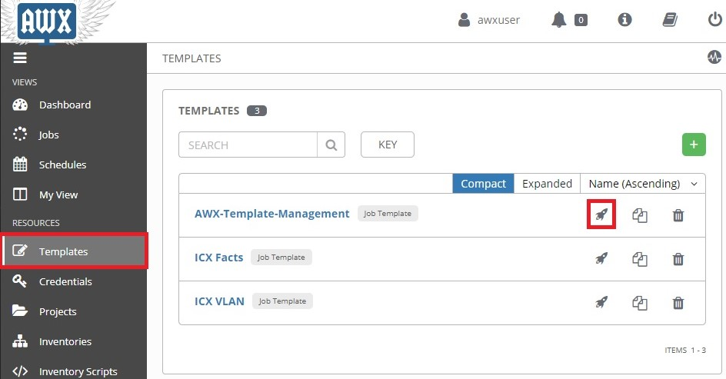

Upon completion the "*AWX-Template-Management*" template automatically generates a survey prompt for itself and ends the play. The template can be viewed by clicking the name of the template on the Job Details page:

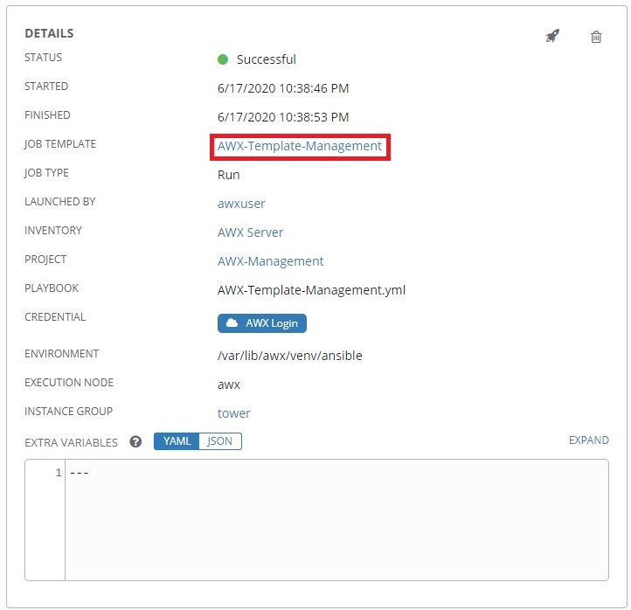

A version number is also added to the **Extra Variables** section of the template page:

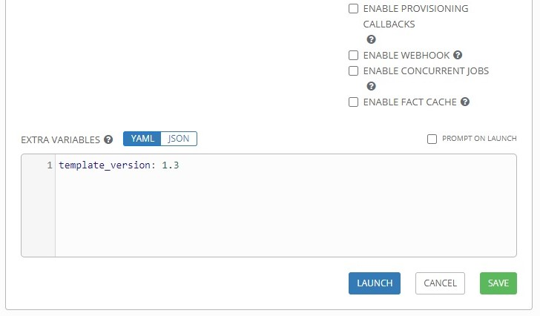

Note: Forcing the template to exit after performing a self-update can be accomplished by removing the "*template_version*" variable, clicking **Save**, then clicking **Launch**. This is useful for updating the list of projects in the Survey Prompt.

# 5. Generating New Templates

## 5.1 Create templates for Ruckus-ICX-AWX-Ansible

Click the **Templates** button from the left navigation bar. Then click the launch () button next to **AWX-Template-Management**:

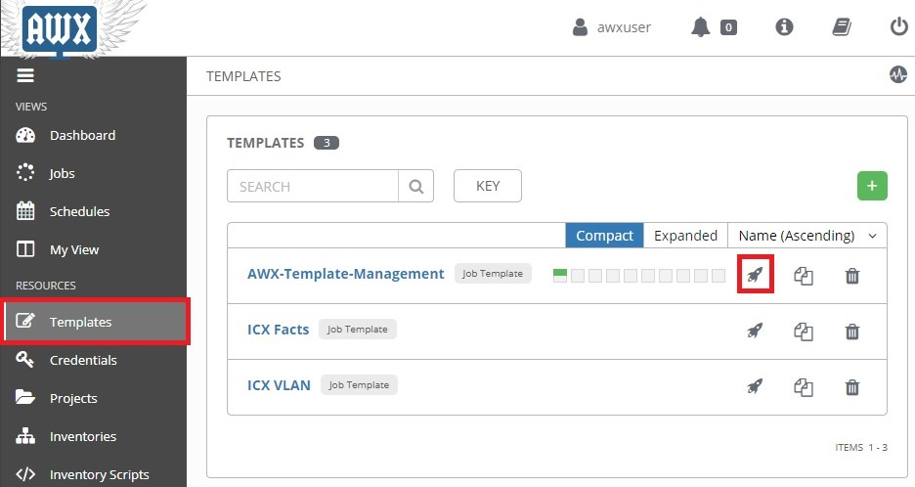

Complete the following fields in the Survey Prompt window that appears:

**TEMPLATE MANAGEMENT FUNCTION:** Select **Create/Update Templates**.

**PROJECT:** Select **Ruckus-ICX-AWX-Ansible**.

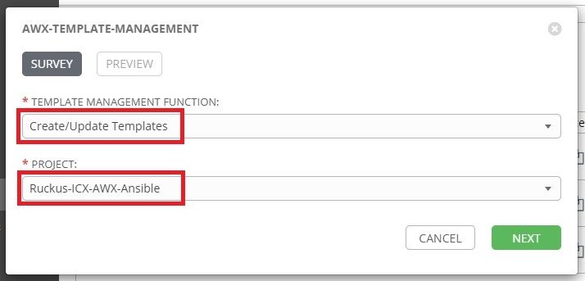

Click **Next** when finished, then click **Launch** on the Preview tab to run the template.

## 5.2 View Templates

Click the **Projects** button from the left navigation bar, then click **Ruckus-ICX-AWX-Ansible** to view the new templates:

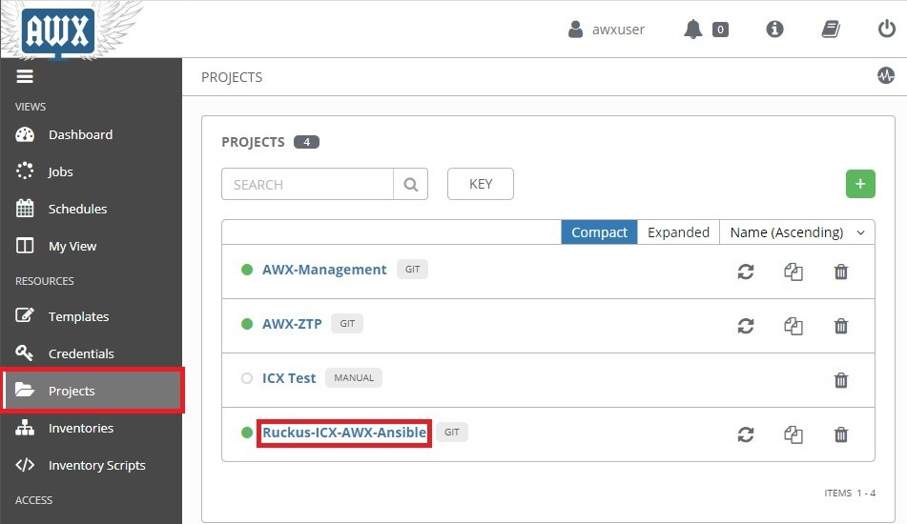

Click the **Job Templates** tab:

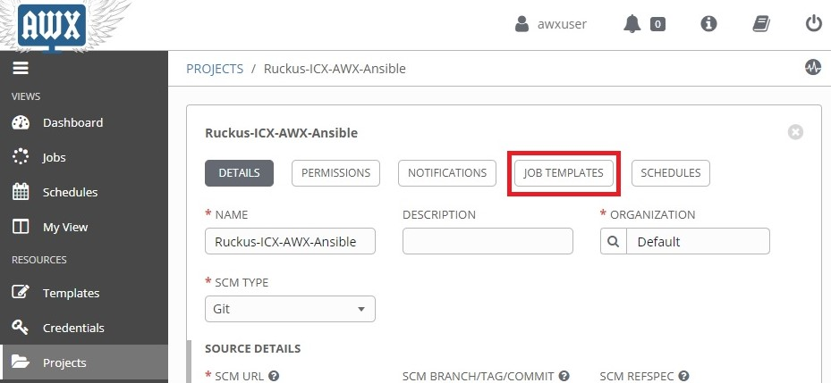

The new templates should now be visible in this tab:

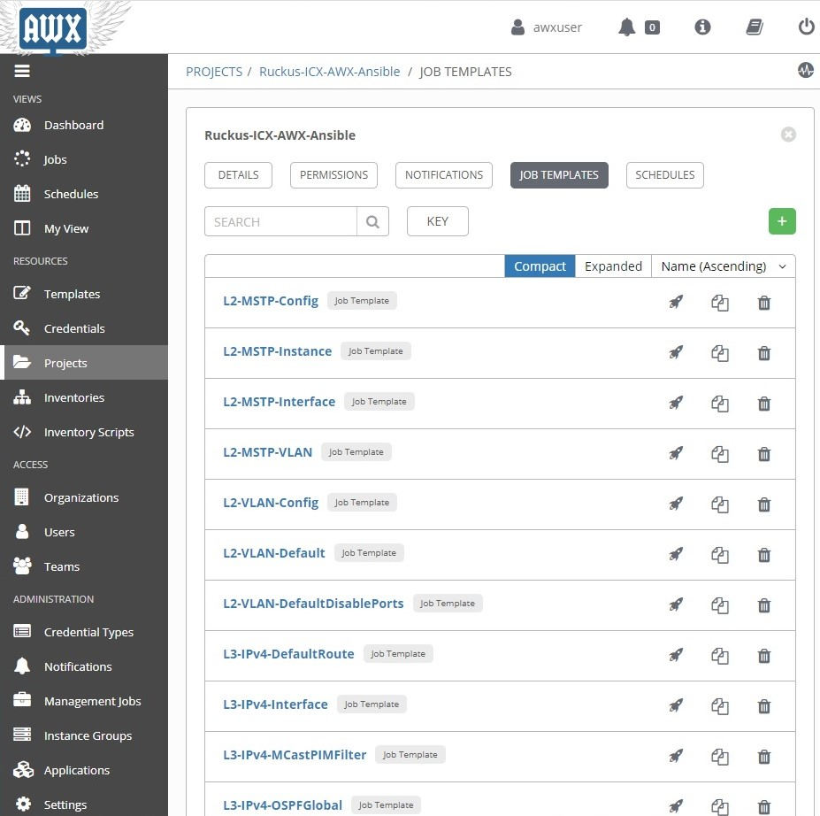

# 6. Updating Playbooks and Templates

Git projects by default do not update local playbooks when changes occur upstream. The following section covers manual and automated methods of updating the templates and playbooks in a project.

## 6.1 Manual update of project playbooks

Click the **Projects** button from the left navigation window, then click the refresh () button for the **Git** projects to sync playbooks with the upstream repository:

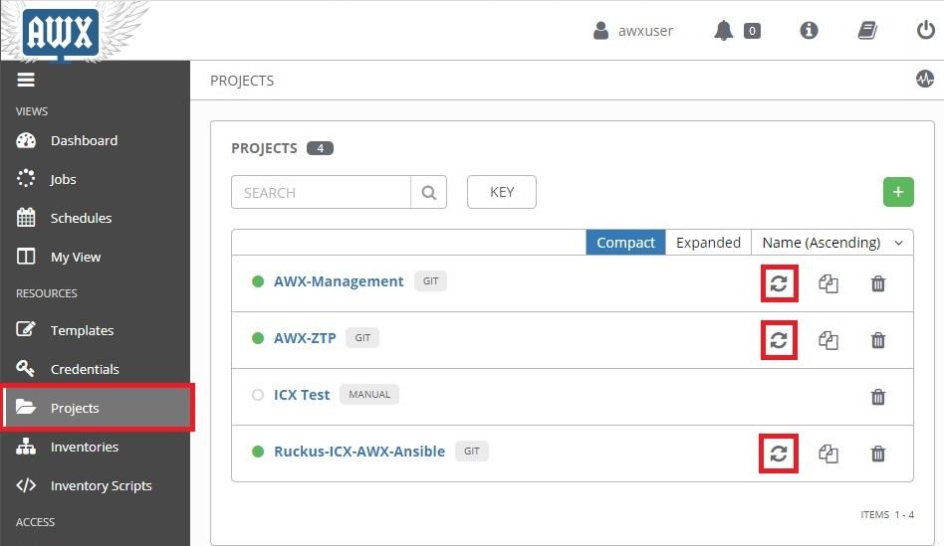

Project templates can be updated by rerunning the "*AWX-Template-Management*" template from the instructions in the "*Generating New Templates*" section above.

## 6.2 Automated update of project playbooks

The following will run through a schedule-based method to update both the playbooks and templates.

Click the **Projects** button from the left navigation menu. Then click the "*Ruckus-ICX-AWX-Ansible*" project:



Click the **Schedules** tab, then click the **+** button:

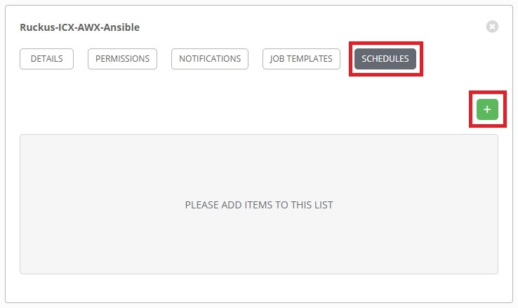

This will open the **Create Schedule** page. Complete the following fields:

**NAME:** Name of the schedule.

**START DATE:** First day the schedule takes effect.

**START TIME:** Time of first run (24-Hour Clock format).

**LOCAL TIME ZONE:** Time zone local to AWX Server.

**REPEAT FREQUENCY:** How often the sync will occur.

The following is an example of a sync that will occur daily at 11:00PM ET starting 6/19/2020:

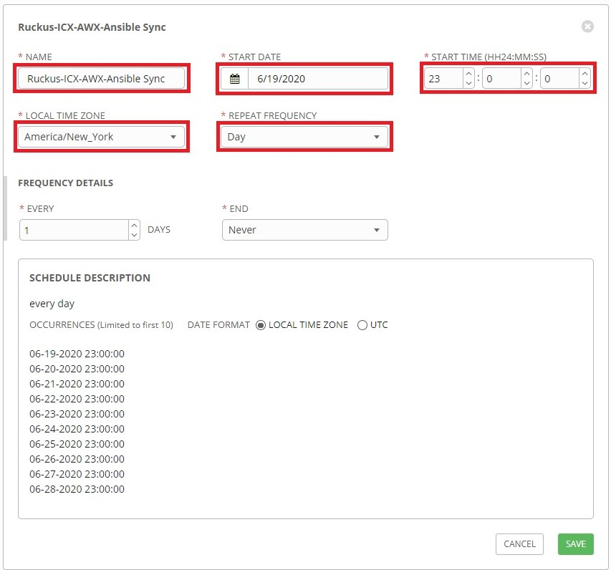

When finished, click **Save**.

If desired, automating the update of other **Git** projects can be set up using the instruction above.

## 6.3 Automated update of project templates

Click the **Templates** button from the left navigation bar, then click "*AWX-Template-Management*":

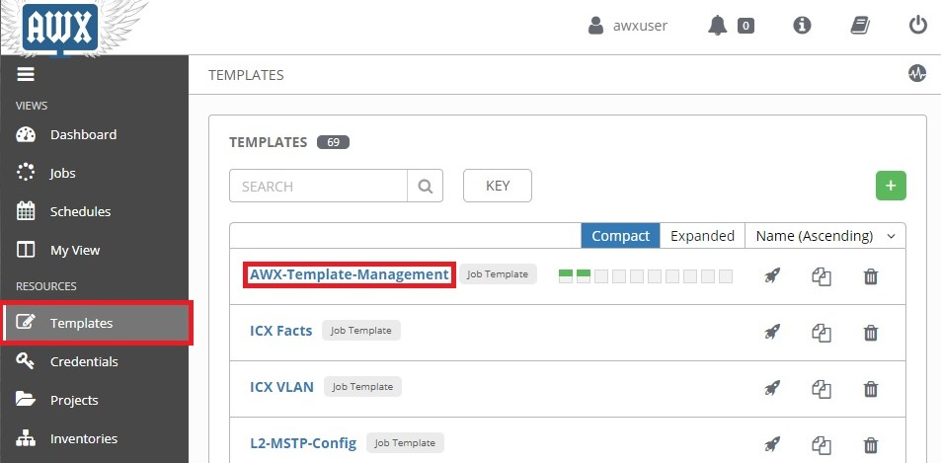

Click the **Schedules** tab, then click the **+** button:

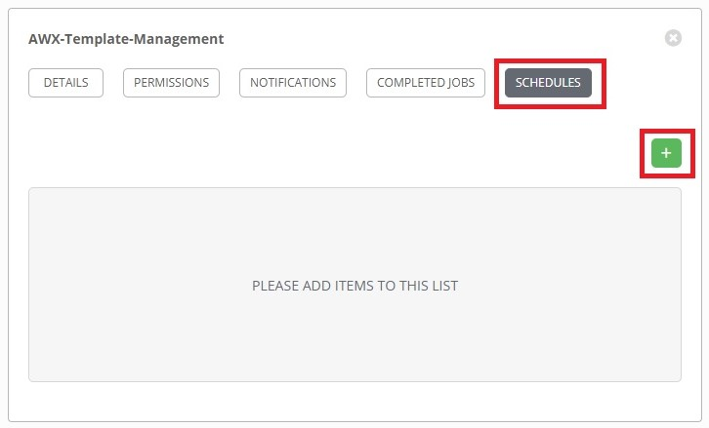

This will open the **Create Schedule** page. Complete the following fields:

**NAME:** Name of the schedule.

**START DATE:** First day the schedule takes effect.

**START TIME:** Time of first run (24-Hour Clock format).

**LOCAL TIME ZONE:** Time zone local to AWX Server.

**REPEAT FREQUENCY:** How often the sync will occur.

The following is an example of a sync that will occur daily at 11:35PM ET starting 6/19/2020:

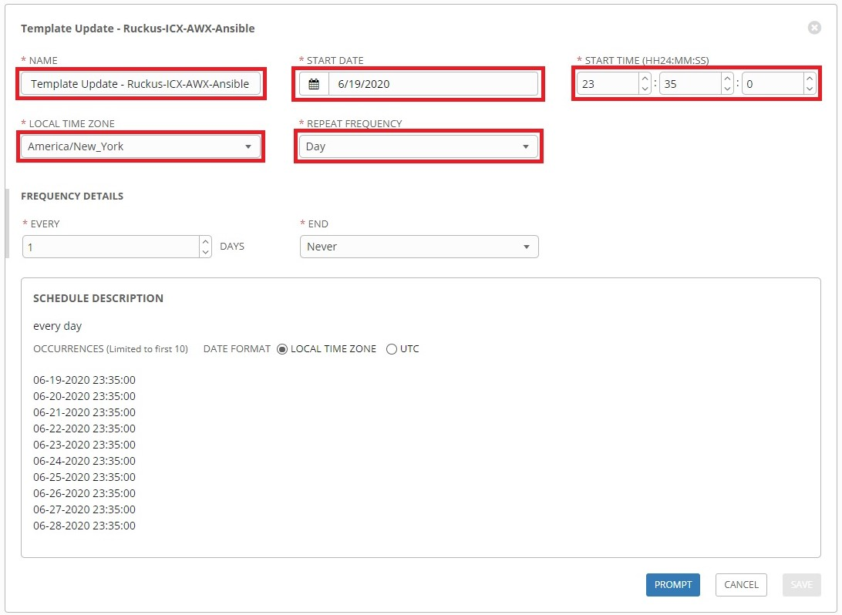

When finished, click the **Prompt** button to open the prompt window.

Complete the following field on the Survey prompt:

**TEMPLATE MANAGEMENT FUNCTION**: Select **Create/Update Templates**.

**PROJECT**: Select **Ruckus-ICX-AWX-Ansible**.

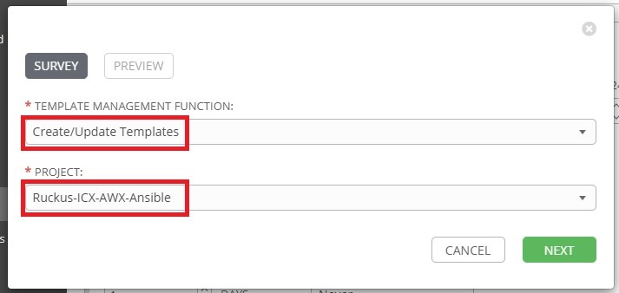

Click **Save** when finished, then click **Confirm** on the next tab to schedule the template to run.

# 7. Custom Template Creation

The 'Ruckus-ICX-AWX-Ansible' project contains a playbook named 'ICX-Custom-Config.yml'. The 'AWX-Template-Management' template does not create a template for this playbook. This playbook can be used to create custom configuration templates. The following provides an example of how to create a custom configuration template.

Click the **+** button on the **Templates** page then click **Job Template** to open the **New Job Template** page. Complete the following fields:

**NAME:** Enter a name for the template.

**DESCRIPTION:** (Optional) Enter a description of the template.

**JOB TYPE:** Select **Run**.

**INVENTORY:** Click the checkbox next to **Prompt On Launch**.

**CREDENTIALS:** Click the checkbox next to **Prompt On Launch**.

**PROJECT:** Select **Ruckus-ICX-AWX-Ansible**.

**PLAYBOOK:** Select **ICX-Custom-Config.yml**.

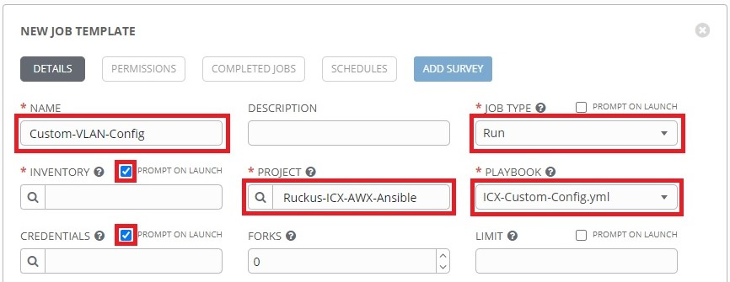

Scroll to the bottom. The switch config will be written as a variable definition in **Extra Variables**:

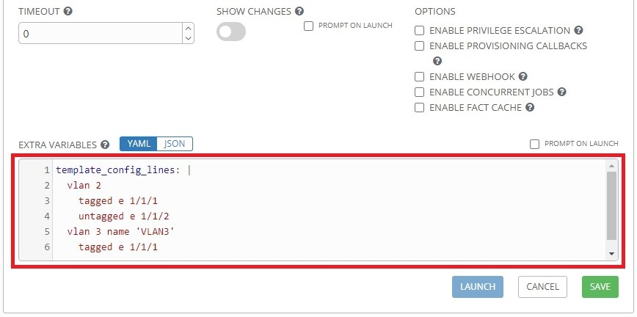

Note: The 'ICX-Custom-Config.yml' playbook pushes the configuration that is defined in the '*template_config_lines*' variable to the switch without performing error checking. Custom templates should be tested first before mass deployment.

# 8. Setup AWX-ZTP

Zero-Touch Provisioning (ZTP) is a feature that allows for automatic provisioning and configuration of network devices when they come online. The 'AWX-ZTP' project utilizes AWX to provide zero-touch provisioning of Ruckus ICX switches.

## 8.1 Setup Localhost SSH Credentials

The 'AWX-ZTP' playbooks connect to the Docker container host with SSH in order to install the necessary components for ZTP. In order to run these playbooks a new credential set will need to be created for SSH.

To add the localhost SSH credentials, click **Credentials** from the left navigation bar, then click the **+** button. Complete the following fields on the **New Credential** page:

**NAME:** Type a name for the credential set.

**CREDENTIAL TYPE:** Select **Machine**.

**USERNAME** & **PASSWORD:** Type in the username and password used to SSH into the AWX server.

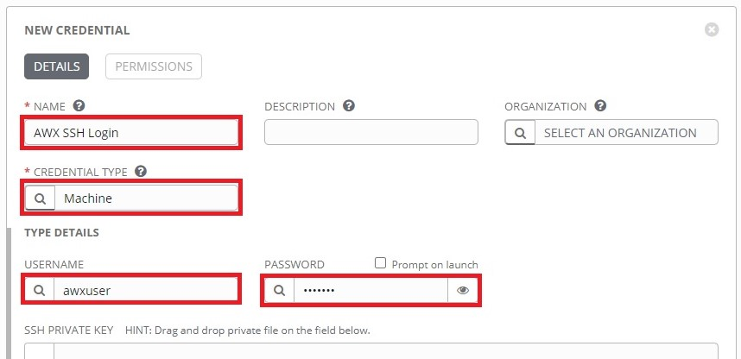

Scroll to the bottom and complete the following fields:

**PRIVILEGE ESCALATION METHOD:** Select **sudo**.

**PRIVILEGE ESCALATION PASSWORD:** Type in the **sudo** password.

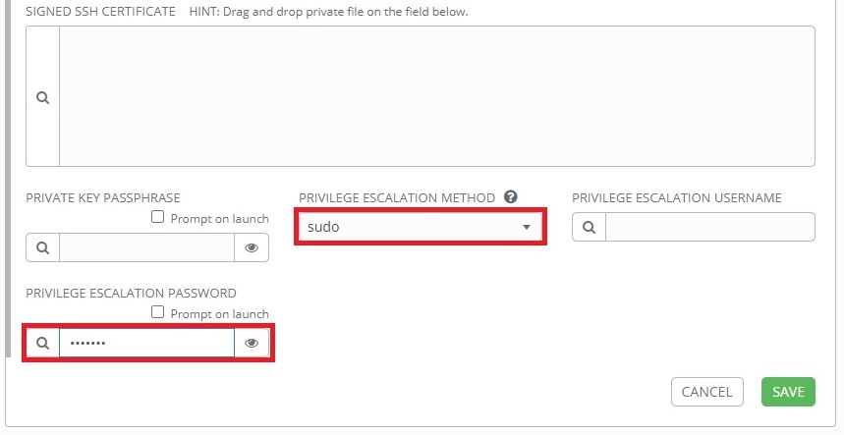

Click **Save** when finished.

## 8.2 Create 'ZTP-Install' Template

Click the **Templates** button from the left navigation bar. Then click the launch () button next to **AWX-Template-Management**:

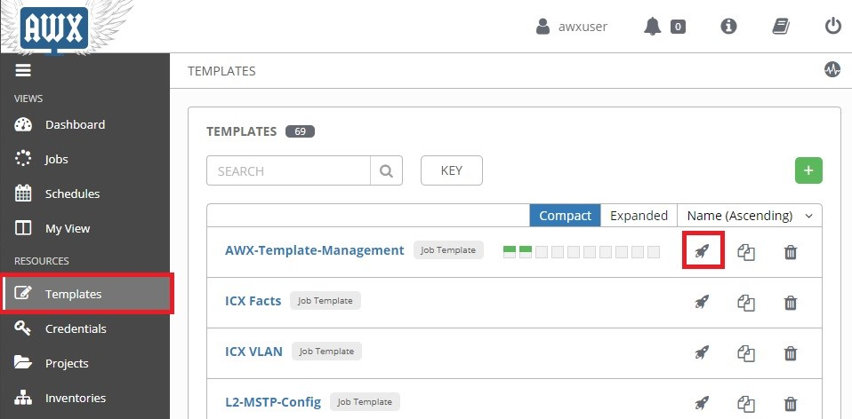

Complete the following fields in the Survey Prompt window that appears:

**TEMPLATE MANAGEMENT FUNCTION:** Select **Create/Update Templates**.

**PROJECT:** Select **AWX-ZTP**.

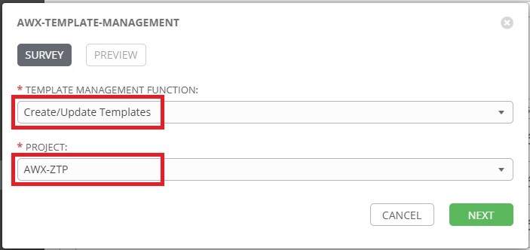

Click **Next** when finished, then click **Launch**. The "*ZTP-Install*" template will appear in the "*AWX-ZTP*" project upon completion.

## 8.3 Launch "ZTP-Install"

The "*ZTP-Install*" template installs several components necessary for ZTP.

Click **Projects** from the left navigation bar, then click on the "*AWX-ZTP*" project:

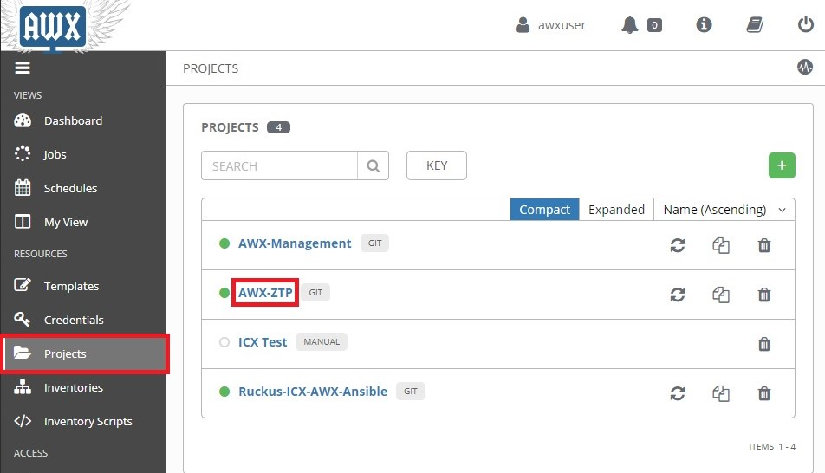

Click the **JOB TEMPLATES** tab, then click the Launch () button next to "*ZTP-Install*":

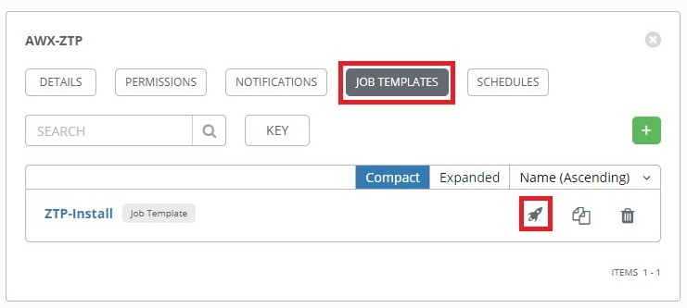

Select the inventory that holds the AWX Server as a host, then click **Next**:

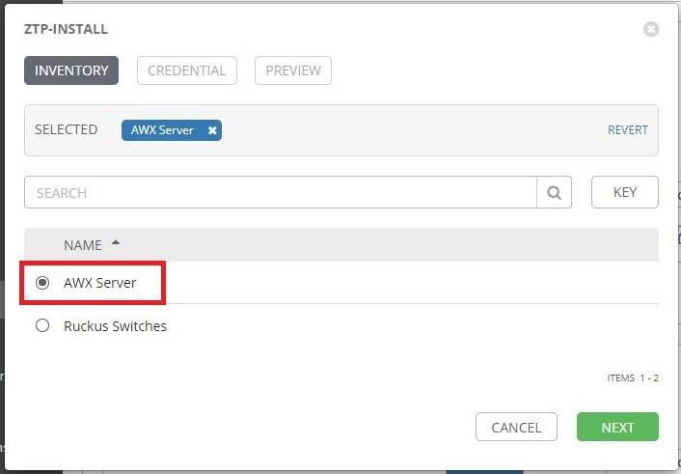

On the **CREDENTIAL** tab, two sets of credentials will need to be selected, one for the SSH Login to the AWX server and one for the REST API credentials. First select the AWX SSH Login credentials, then open the drop-down menu for **Credential Type**:

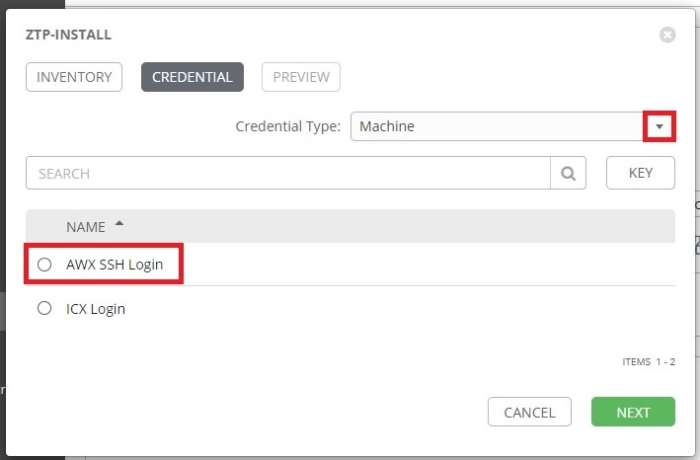

Select **AWX REST API** from the drop-down menu:

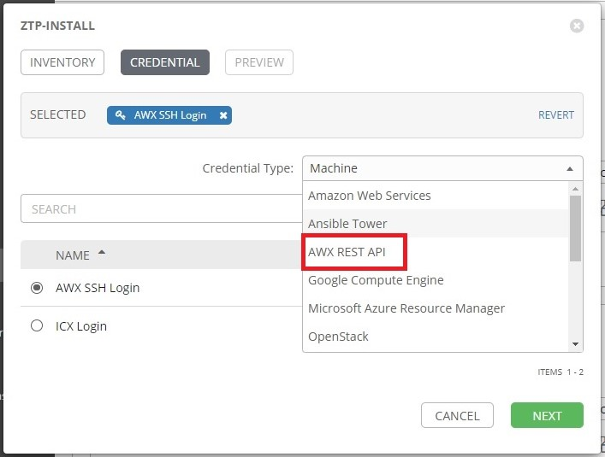

Select the credentials for the AWX REST API:

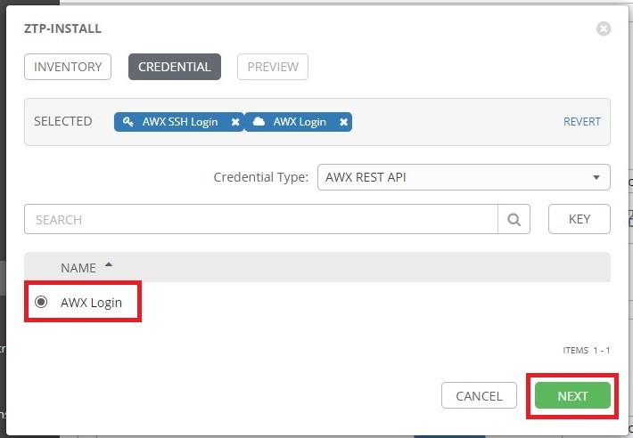

The "*ZTP-Install*" template will create a new AWX inventory for ZTP hosts. Change the name of the inventory or leave it at the default, then click **Next**:

Click the **Launch** button to start the ZTP install:

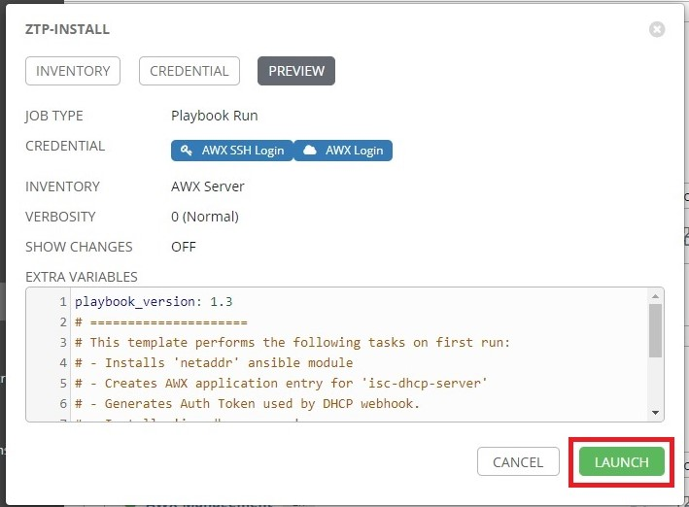

In addition to installing necessary components for ZTP, the "*ZTP-Install*" template also creates two additional templates: "*ZTP-Configure*" and "*ZTP-Regen-AuthToken*". The "*ZTP-Regen-AuthToken*" template can be run to regenerate the AWX Application Authentication Token used by the DHCP webhook.

## 8.4 Launch "ZTP-Configure"

The "*ZTP-Configure*" template can perform several tasks including:

Configures a secondary interface on the AWX server with an IP address.

Creates a provisioning inventory in AWX. Hosts discovered by DHCP are placed here.

Creates a post-provisioning inventory in AWX. Provisioned hosts are placed here.

Configures DHCP on the AWX server.

Creates an IP pool for configuring a static IP address on a host interface.

Creates a hostname pool to configure a hostname on a host.

The following provides a guide for running the "*ZTP-Configure*" template.

Click **Projects** from the left navigation bar, then click on the "*AWX-ZTP*" project:



Click the **JOB TEMPLATES** tab, then click the Launch () button next to "*ZTP-Configure*":

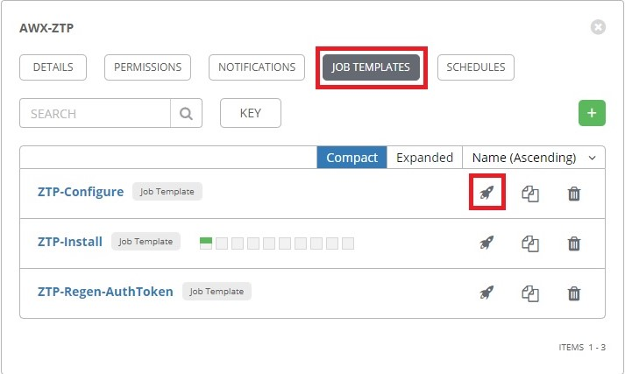

Complete the following fields:

**PROVISIONING INVENTORY:** Name of ZTP Inventory to create.

**SELECT ZTP INTERFACE:** Select the interface configure a static IP address on.

**INTERFACE IP ADDRESS AND MASK:** Enter the IP address and mask to statically assign to the interface.

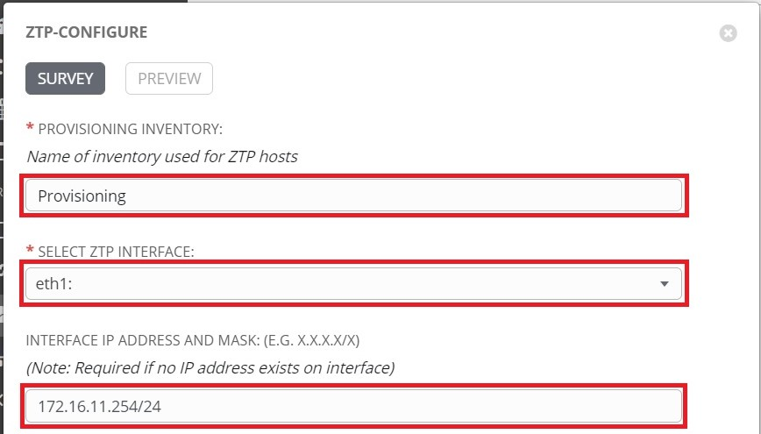

Scroll down to complete the DHCP config fields:

**DHCP SUBNET IP AND MASK:** Enter the DHCP subnet prefix and mask.

**DHCP SUBNET RANGE:** Enter the IP range to be used as the DHCP allocation pool.

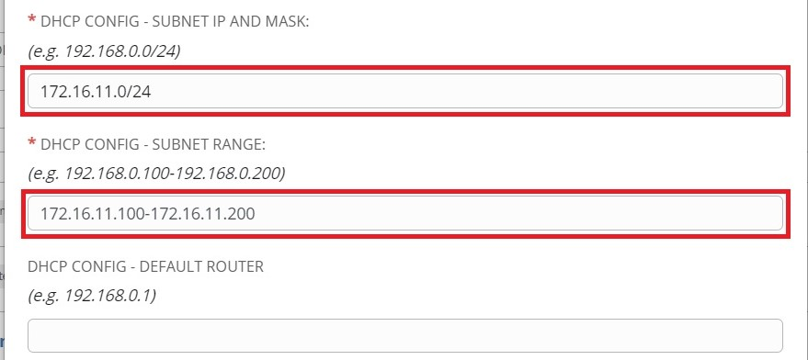

Scroll down to complete the remaining fields, then click **Next** when finished:

**STATIC IP POOL SWITCH INTERFACE:**  Interface on switch where static IP will be configured.

**STATIC IP POOL SUBNET:** Enter the prefix and mask of static IP pool network.

**STATIC IP POOL RANGE:** Enter the IP range to be used to allocate static IP addresses.

**HOSTNAME POOL BASE NAME:** Enter the base name to be used for hostname allocation. **POST-PROVISIONING INVENTORY NAME:** Enter the name of the post-provisioning inventory to be created.

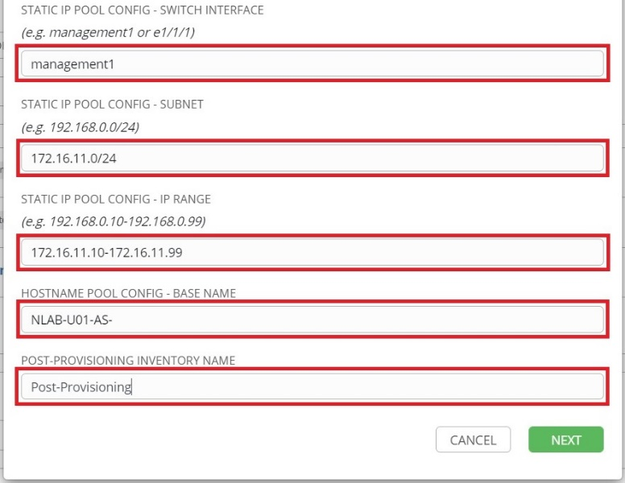

Click **Launch**:

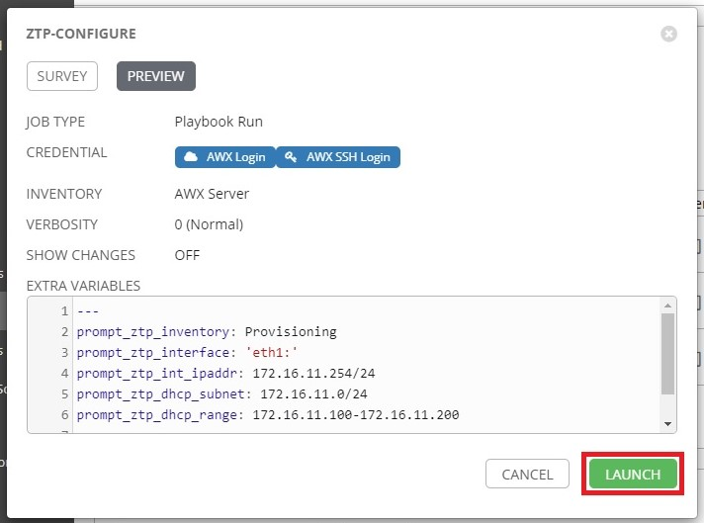

When the template has successfully completed, the DHCP server will begin listening for hosts.

Note:

* The 'Provisioning-Finalize' template handles the assignment of static IP addresses from the pool as well as the assignment of hostnames and moving the switch from the provisioning to the post-provisioning inventory.
* If the **Static IP Pool Interface** is left blank with the rest of the static IP pool configuration defined, the 'Provisioning-Finalize' template will replace the IP address on the interface that received a DHCP address with an address from the static IP pool.

## 8.5 Workflow Creation

A workflow created in AWX can be automatically launched by the "*Provisioning-Init-Login*" template. The following provides an example of creating a workflow.

Click **Templates** from the left navigation bar. Then click the **+** button and select **Workflow Template**:

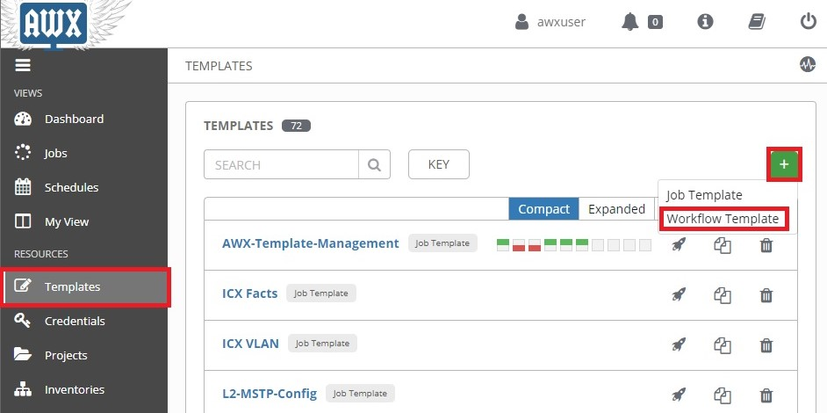

Type in a name for the workflow, then click **Save**:

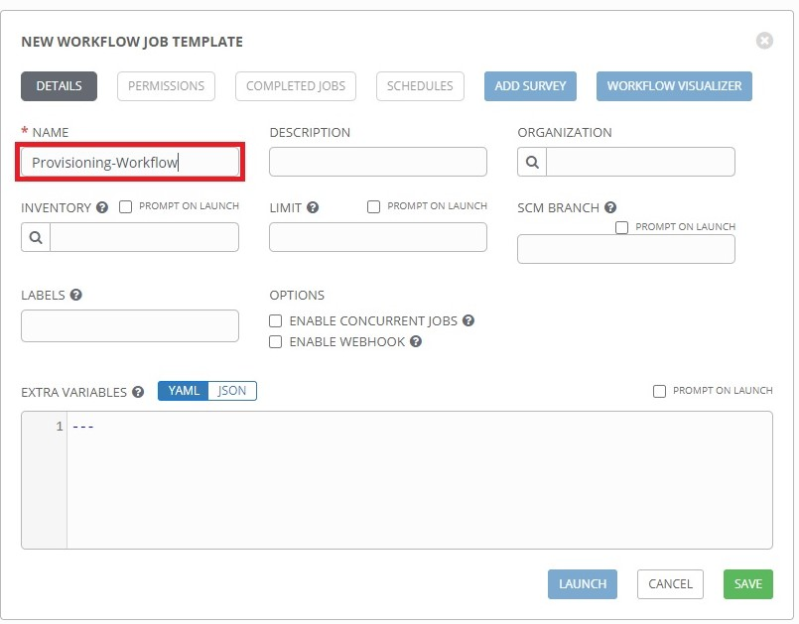

The **Workflow Visualizer** will open. Click the **Start** button:

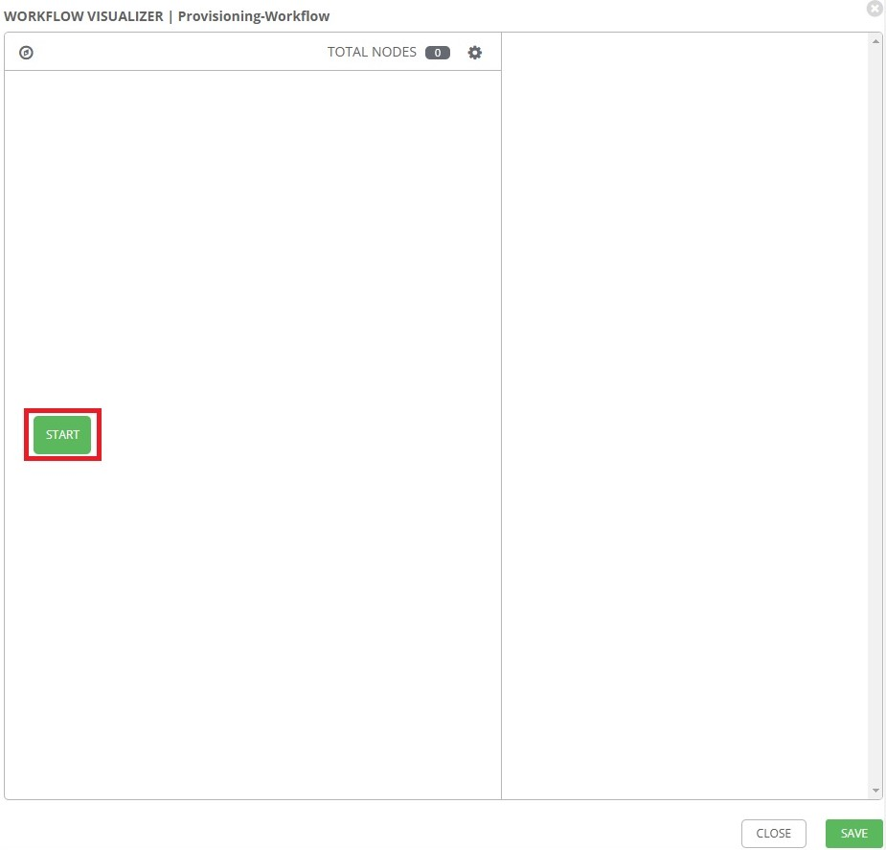

The list of templates will appear on the right. The templates can be added to a workflow here. For this example, click on the **Remote-User-LocalAcct** template, then click **Prompt**:

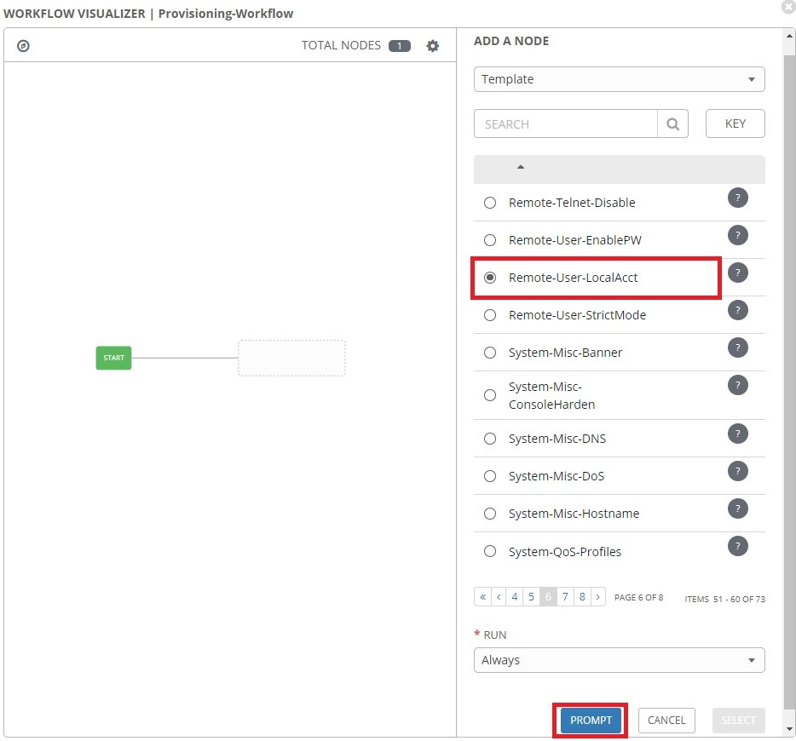

Select the name of the provisioning inventory, then click **Next**:

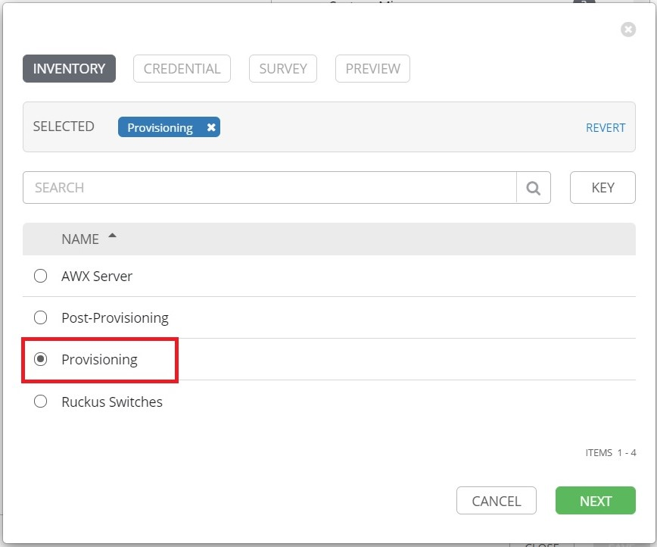

Select the **ZTP_Default_Login** credentials:

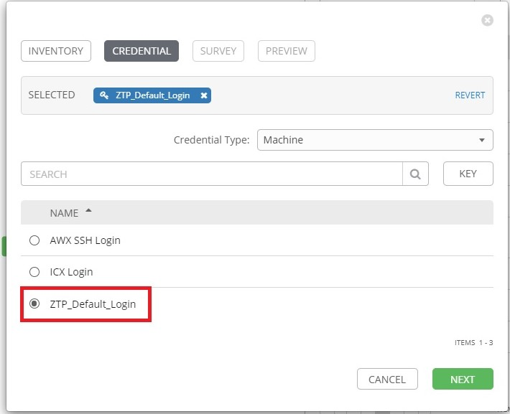

Type in a username and password to add as a local account on the switch:

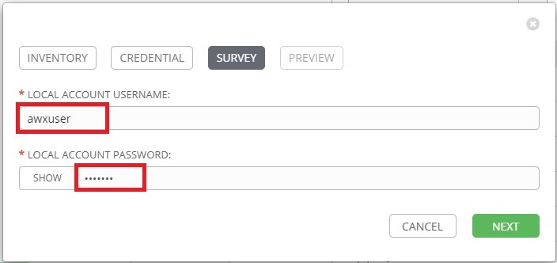

When finished, click **Next.**

Click **Confirm**:

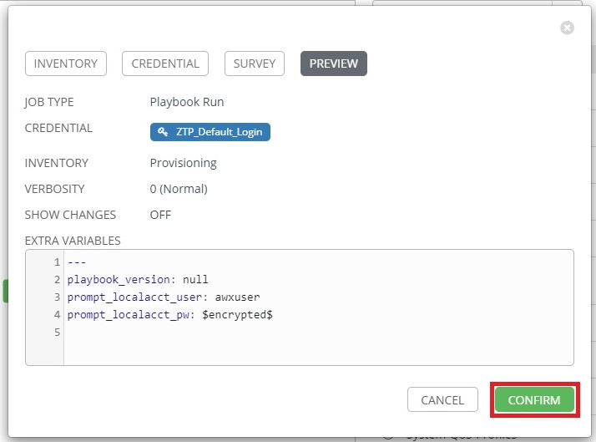

Click **Select** to add the job to the workflow:

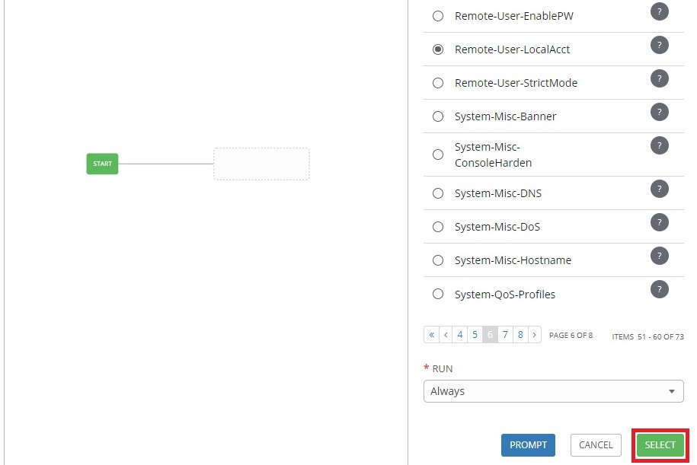

Click the  button to add a node:

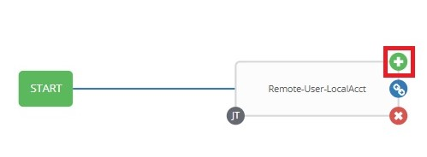

Select another template then click prompt. For this example, the "*L2-VLAN-Config*" is selected:

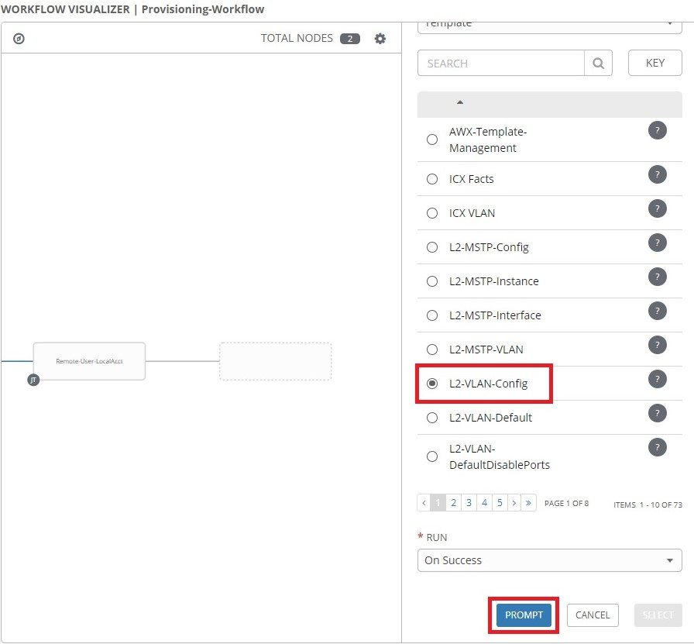

Select the name of the provisioning inventory, then click **Next**:



If the login credentials configured for the job in the previous step match the credentials that are saved in AWX, they can now be selected:

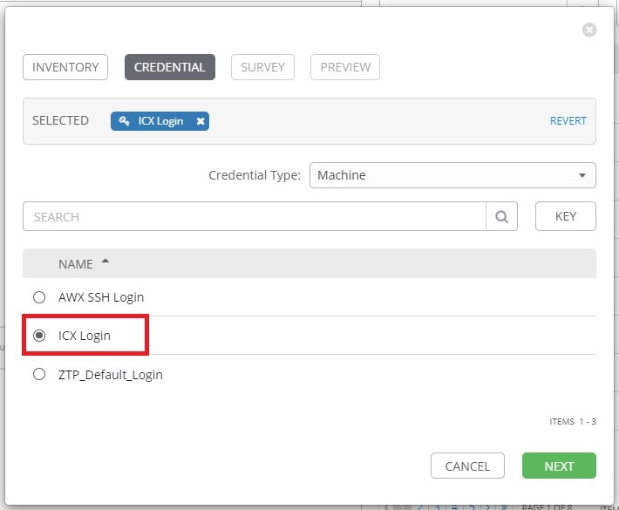

Click **Next** when finished.

Complete the Survey prompt on the next page, then click **Next.** In this example, a VLAN named "*Workstation*" with an ID of 301 will be created and ports 1/2/1 and 1/2/2 will be tagged:

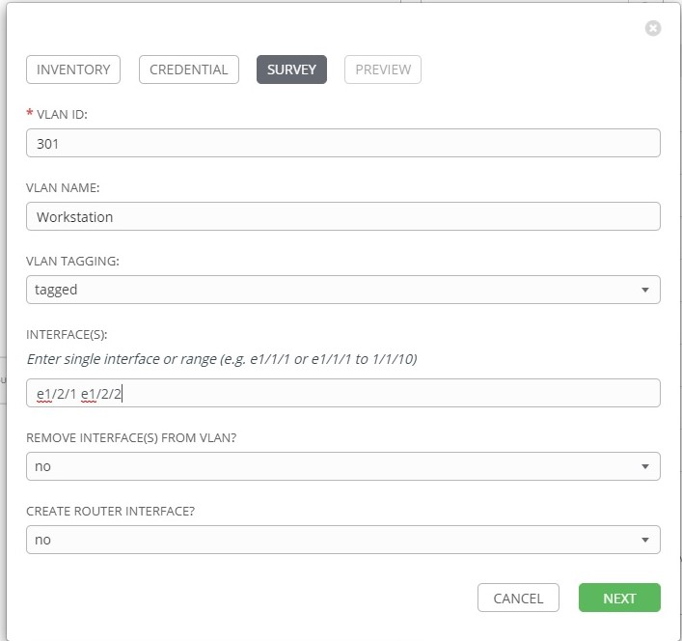

Click **Confirm** on the next window to close the prompt window.

Click **Select** to add the job to the workflow:

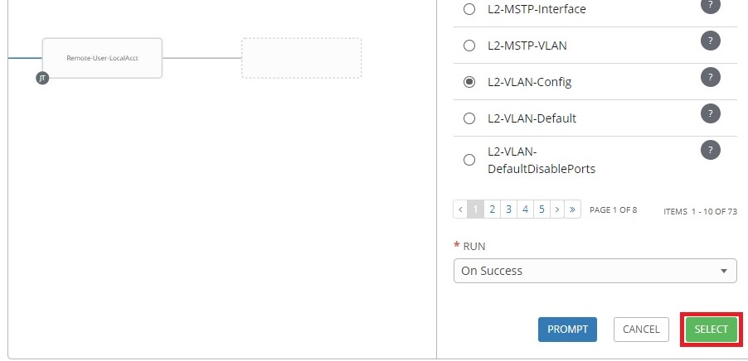

Other templates can be added to the workflow to build out a baseline configuration. Other workflows can also be added to a workflow. The last template to add to the provisioning workflow should be the 'Provisioning-Finalize' template. This template will configure a static IP address onto the switch, configure a hostname and move the switch to the post-provisioning inventory.

To add the 'Provisioning-Finalize' template to the workflow, click the  button:

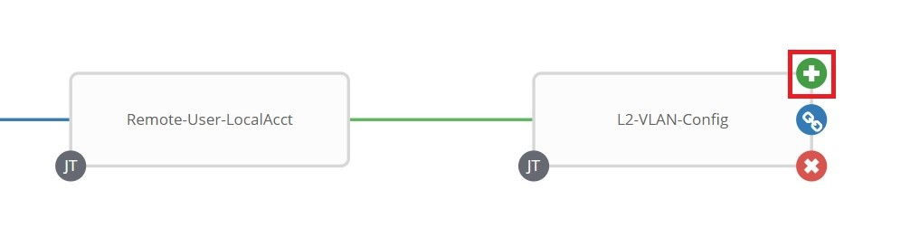

Select 'Provisioning-Finalize' from the list of templates on the right:

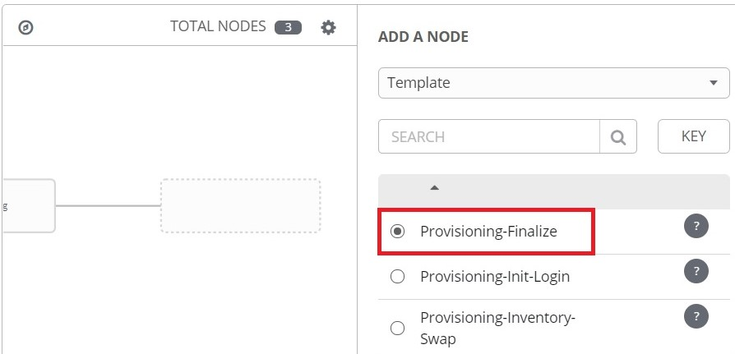

Click **Prompt** at the bottom of the template list:

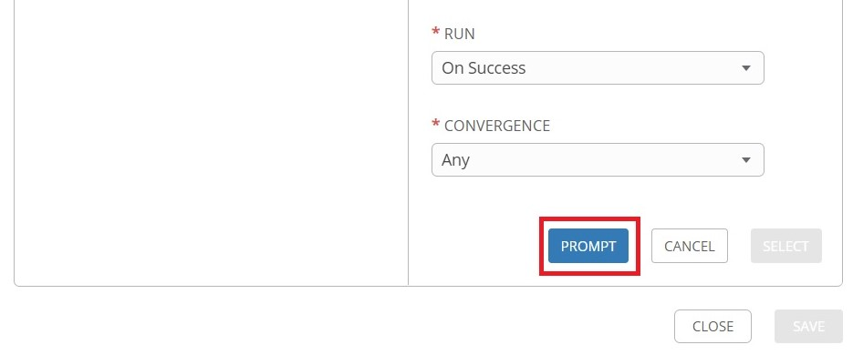

Select the name of the provisioning inventory, then click **Next**:



The 'Provisioning-Finalize' template requires two set of credentials, the switch login credentials and the REST API credentials. First select the credentials used for switch login, the click the drop-down menu for **Credential Type**:

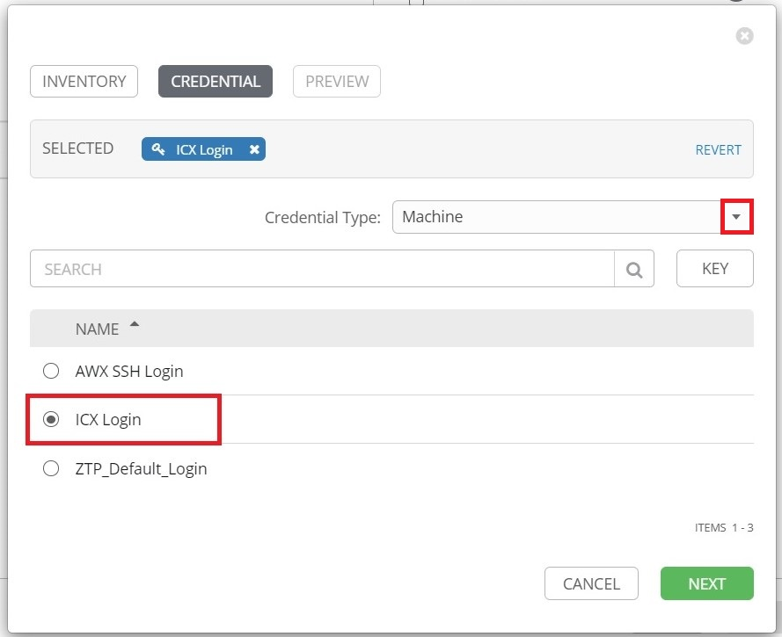

Select **AWX REST API** from the drop-down menu:

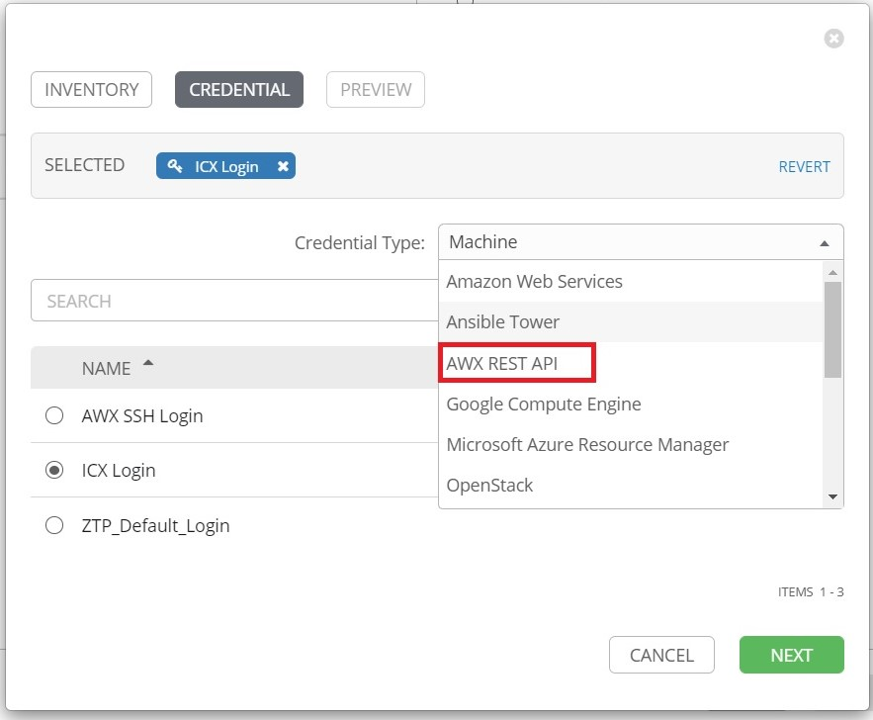

Select the credentials for the AWX REST API, then click **Next**:

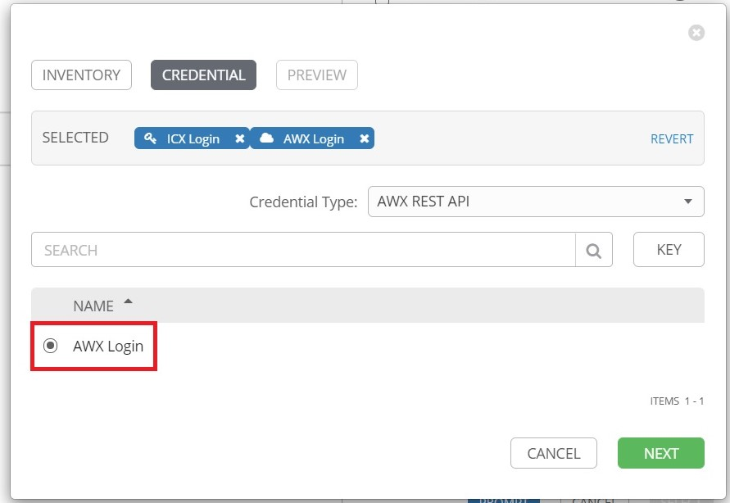

Click **Confirm** on the next page to close the Prompt window.

Click **Select** to add the job to the workflow:

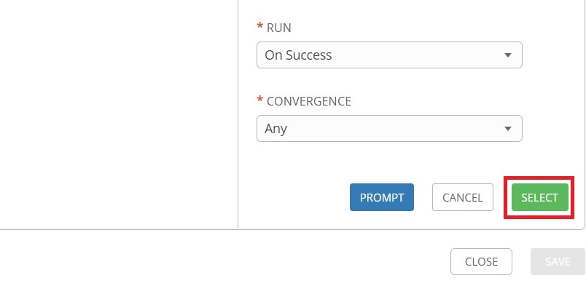

Click **Save** to save the workflow:

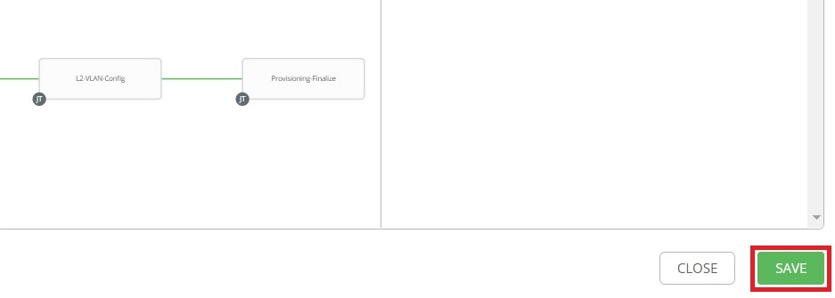

## 8.6 Adding Workflow to ZTP

Now that the workflow is created, it can be added to ZTP.

Click **Inventories** from the left navigation bar, the select the provisioning inventory:

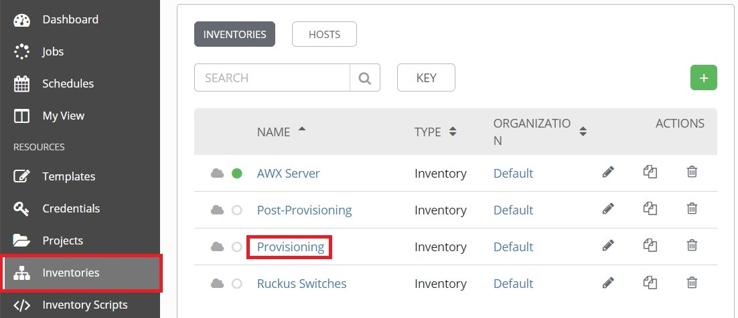

Find the inventory variable named "*icx_inv_ztp_vars.provisioning_vars.workflow*" and define it with the name of the workflow as shown below, then click **Save**:

